Illustrative value of Bronchoalveolar Lavage In diagnosis of Patients with Ventilator Associated Pneumonia

Background:The diagnosis of ventilator-associated pneumonia (VAP) remains a challenge, with clinicians mainly relying on clinical, radiological, and bacteriologic strategies to manage patients with VAP.
Aims: Illustrates value of Bronchoalveolar lavage in diagnosis of Patients with Ventilator Associated Pneumonia

Settings and Design: This was a single-center prospective diagnostic accuracy study done in the 22-bedded intensive care unit of Benha university hospital.

Materials and Methods: Patients aged ≥18 years, on mechanical ventilation for ≥48 h, and with clinical suspicion of VAP (fever, leukocytosis, and increased tracheal secretions) and chest x-ray infiltrates .Every patient underwent first non-bronchoscopic protected bronchoalveolar lavage (NP-BAL) and then bronchoscopic BAL (B-BAL) for sample collection. Clinical Pulmonary Infection Score (CPIS) was calculated for each patient and the collected samples were evaluated in laboratory using standard microbiological techniques.

Statistical Analysis Used: The sensitivity, specificity, positive predictive value, and negative predictive value of NP-BAL and B-BAL for the diagnosis of VAP were calculated taking CPIS score of >6 as index test for the diagnosis of VAP.

Results: forty patients were included in the study. Both NP-BAL and B-BAL had concordance with the CPIS at 92.2%. The concordance between NP-BAL and B-BAL was better at 97,36% with a kappa coefficient of 0.89% (P = −0.001). The yield and sensitivity of NP-BAL were comparable to that of B-BAL.

Conclusions: The blind NP-BAL is an equally effective method of airway sampling and could be a better alternative to replace more invasive B-BAL for microbiologic diagnosis of VAP.
Keywords: Bronchoalveolar lavage, bronchoscopy, ventilator-associated pneumonia

Introduction: Ventilator-associated pneumonia (VAP) has an incidence of 5%–40% in critically ill patients and up to 27% in mechanically ventilated patients.[1] And mortality rates range from 20% to 50% and reaching upto 70% when caused by multidrug resistant pathogens.[1,2,3].The diagnosis of VAP remains a challenge and has conventionally been made based on clinical signs and microbiologic diagnostic techniques. But the clinical signs and symptoms lack both sensitivity and specificity and the standard microbiologic diagnostic procedure is still an open-ended debate.[4] The Clinical Pulmonary Infection Score (CPIS) was proposed by Pugin et al.[5] It is based on six variables (fever, leukocytosis, tracheal aspirates, oxygenation, radiographic infiltrates, and semiquantitative cultures of tracheal aspirates). As a diagnostic tool for VAP, CPIS value of >6 has sensitivity and specificity of 93% and 100%, respectively.[5] Microbiological diagnostic techniques include invasive or non-invasive sampling either from proximal or distal airway.
SUBJECTS AND METHODS:
Study design and participants
We conducted a prospective diagnostic accuracy study between August 2020 to August 2021 and forty patients with clinical and radiological diagnosis of VAP were recruited in our study. 2 sample of distal airway (first by NP-BAL then B-BAL) were taken from every patient then sent for microbiological examination. We compared two methods of distal airway secretions to diagnose VAP. The study was performed at the 22-bedded intensive care unit (ICU) of Benha university hospital after approval from Ethics Committee of the Banha College of Medicine. . Informed consent from the patient's next of kin was taken regarding enrollment of the patient in the study.

Inclusion and exclusion criteria
Patients were ≥18 years of age, on mechanical ventilation for ≥48 h, and with clinical suspicion of VAP(based on the criteria given by Johanson et al). Patients with any contraindication to bronchoscopy like bleeding diathesis, profound refractory hypoxemia, and malignant cardiac arrhythmias were excluded from the study.
Data collection
Demographic information, symptoms, comorbidities, indication and duration of mechanical ventilation were recorded at enrollment. Blood sample was taken daily for total leukocyte count , chest radiography was performed to identify new infiltrate and arterial blood sample to assess partial pressure of oxygen/fraction of inhaled oxygen (PaO₂/FiO₂). Tracheal secretions were assessed every day for character (purulent or not).

Samples collection by various methods
Each patient, with suspicion of VAP, CPIS[5] was calculated on the day of sample collection. Two respiratory samples were collected from all patients, first NP-protected BAL (NP-BAL or Mini-BAL) then B-BAL to avoid contamination of the distal airways. Before either procedure, FiO₂ was adjusted to 1.0 for 30 min with monitoring of all vital signs including heart rate; blood pressure, temperature, and oxygen saturation were monitored during the entire procedure. 3–5 mg of intravenous midazolam was used for sedation if required.

Mini-bronchoalveolar lavage
NP-BAL was performed by double catheter technique. A sterile suction catheter of size 16 Fr was cut 2–3 cm from the distal end to give a final length of about 47–48 cm. It was inserted through the endotracheal tube and blindly advanced into the distal airways till resistance was felt, and then, a second 50 cm long, sterile suction catheter of 8 Fr size was passed through the first catheter and advanced as far as possible. 20 mL of sterile saline was then instilled into the distal airways through the inner tube, which was aspirated and collected in a sterile container..

Bronchoscopic bronchoalveolar lavage
The bronchoscope (Karl Storz Spies 11900BP Bronchoscope) was introduced and the tip was wedged to distal bronchi draining the bronchopulmonary segment of interest as determined by chest radiograph. Right lower lobe was sampled in case of diffuse/bilateral lung infiltrates. Three aliquots of fifty millimeter of normal saline were used as the instillate. A saline filled 50 mL syringe was attached to the side port of the bronchoscope and the saline was instilled slowly and steadily. It was recovered immediately into a sterile container by gentle suction. Quantity of aspirate was noted. After bronchoscopy, FiO₂ was kept at 1.0 for 1 h.

Laboratory tests
The collected samples were immediately transported for bacteriologic examination and quantitative cultures to our microbiology laboratory within 1 h of collection. NP-BAL and B-BAL samples were divided into two: the first half was centrifuged (1500 rpm.min⁻¹ for 10 min) and used for Gram stain. Semiquantitative culture of the second half of the samples was done using calibrated loop method,[7] in which 0.01 ml of specimen was plated directly into chocolate agar, blood agar, and MacConkey agar. Plates were incubated at 35°C–37°C for 24 h. Numbers of colonies grown were converted into number of CFU.ml⁻¹. Bacterial identification was done using standard microbiologic techniques. The threshold of 10⁴ CFU/ml was applied to NP-BAL and B-BAL for the diagnosis of VAP.

Statistical analysis
The results were collected, tabulated, and statistically analyzed by by the IBM compatible personal computer with SPSS statistical package version 20. Results were expressed in frequency, percentage, or mean and standard deviation when appropriate. The sensitivity, specificity, positive predictive value (PPV), and negative predictive value (NPV) of NP-BAL and B-BAL for the diagnosis of VAP were calculated by defining true or false positives and true or false negatives against the reference standard of CPIS score of >6. The compatibility of B-BAL and NP-BAL results for all cases was evaluated with kappa statistics. A two-tailed P < 0.05 was considered statistically significant. McNemar test was used to analyze qualitative data with repeated measures. p-value of McNemar test (p < 0.05 indicates significant difference between the two measures).
Results: Samples of NP-BAL and B-BAL were collected from all 40 patients. The diagnostic value of both sampling techniques is described in Table 1. The results of NP-BAL were comparable to that of B-BAL in Table 2. The concordance between non-BAL and BAL-based diagnosis was 97.36 % with Kappa statistic of 0.89 (p < 0.001) indicating perfect concordance between the two measures. The concordance and kappa coefficient of both sampling techniques with CPIS is shown in Table 3. NP-BAL had a concordance with CPIS at 92.1% with Kappa statistic of 0.63 (p < 0.001). B-BAL had concordance of 92.5% with Kappa statistic of 0.724 (p < 0.001).​

Table (1): Comparison between BAL- and non-BAL-based diagnoses among the study patients
Procedure | Sensitivity | Specificity | PPV | NPV | Accuracy
BAL | 92.1 | 100 | 100 | 40 | 92.5
Non-BAL | 91.4 | 100 | 100 | 50 | 92.1

Table (2) Concordance between BAL and non-BAL
 |  | BAL |  | p-value¥ | Kappa | p-value ^{ǂ}
 |  | Positive | Negative
Non-BAL | Positive | 32 | 0 | 1.00 | 0.89 | <0.001*
 | Negative | 1 | 5

Table (3) Comparison between BAL and non-BAL cultures against CPIS of 6 or more for VAP diagnosis

 |  | Diagnosis based on CPIS ≥ 6 |  | p-value¥ | Kappa | p-value ^{ǂ}
 |  | Positive | Negative
BAL | Positive | 35 | 0 | 0.5 | 0.724 | <0.001*
 | Negative | 3 | 2
Non-BAL | Positive | 32 | 0 | 0.25 | 0.63 | <0.001*
 | Negative | 3 | 3
BAL- and non-BAL ROC curves among the study patients is described in Table 4. The area under ROC curve of BAL-based diagnosis of VAP was significantly larger than the area of chance (0.973 vs. 0.5) with p-value of 0.007 indicating a significant diagnostic value and the same for BAL with p-value of 0.009 indicating a significant diagnostic value. The difference between the two areas under the ROC curves of BAL and non-BAL-based diagnosis of VAP shown in Table 5. This difference was not significant represented by an area difference of 0.014 and p-value of 0.317 concluding that non-BAL-based diagnosis did not offer superiority to BAL-based diagnosis of VAP. ROC curve of BAL-based VAP diagnosis compared to CPIS ≥ 6 is shown in Figure 1, while ROC curve of non-BAL-based VAP diagnosis compared to CPIS ≥ 6 is shown in Figure 2 and Comparison between ROC curves of BAL-based and non-BAL-based VAP diagnosis compared to CPIS ≥ 6 is shown in Figure 3
Table (4): BAL- and non-BAL ROC curves among the study patients
Procedure | AUC of ROC curve | SE | Lower limit | Upper limit | p-value
BAL | 0.973 | 0.025 | 0.924 | 1.00 | 0.007*
Non-BAL | 0.957 | 0.033 | 0.892 | 1.00 | 0.009*

Table (5): BAL- and non-BAL ROC curves difference among the study patients
Difference between ROC curves | SE | Lower limit | Upper limit | p-value
0.014 | 0.208 | -0.014 | 0.042 | 0.317

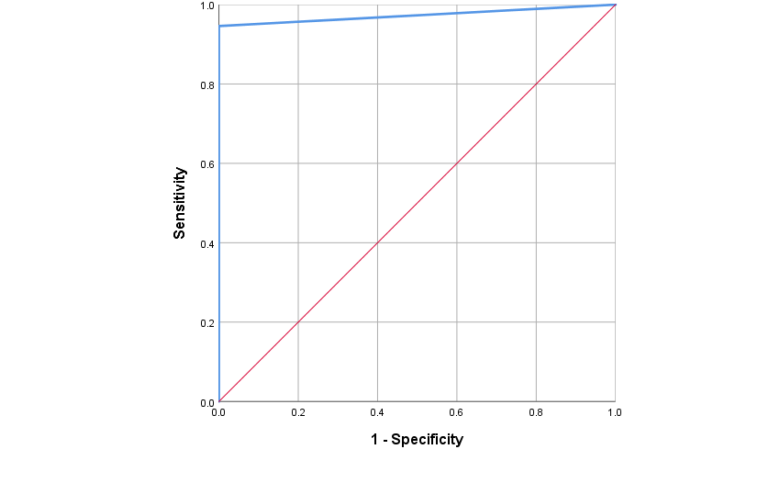
Figure (1): ROC curve of BAL-based VAP diagnosis compared to CPIS ≥ 6
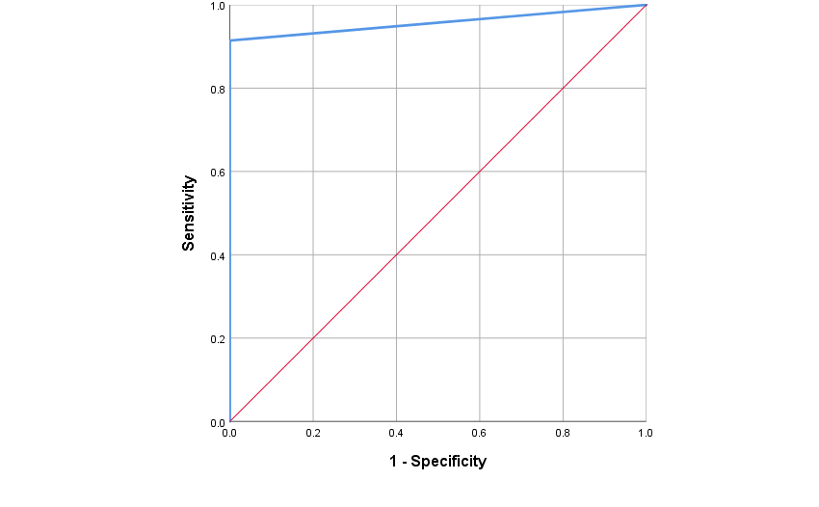
Figure (2): ROC curve of non-BAL-based VAP diagnosis compared to CPIS ≥ 6
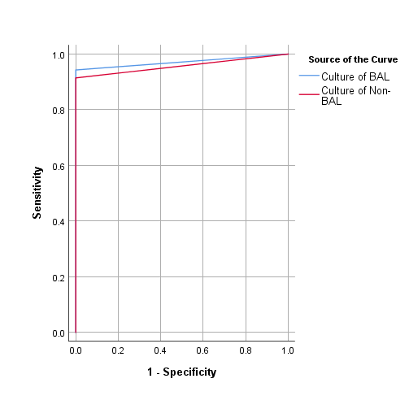
Figure (3): Comparison between ROC curves of BAL-based and non-BAL-based VAP diagnosis compared to CPIS ≥ 6
Discussion:
Even though the B-BAL has several advantages, the most important being the ability to direct sampling into the desired lobe, it is important to emphasize its limitations in resources as fiberoptic bronchoscopes and qualified operators are not always readily available thus potentially delaying pathogen-directed treatment with its harmful consequences [6]. Kollef et al. mentioned that NB-BAL is a simple procedure which can be performed by resident doctors and paramedics posted at the ICU after a small demonstration which can reduce the cost of management of VAP [7]. Similar benefits should be expected in our setting as the catheters and mucus extractors used in our study has low cost. This study analyzed the performance of the double catheter technique of NB-BAL with the B-BAL in the same patient by using the same quantitative threshold. The reference standard in this study was the clinical pulmonary infection score (CPIS) with a total score more than six for the diagnosis of VAP. [2]. Who was in agreement, Pugin et al⁽⁵⁾ and Leal-Noval et al⁽⁸⁾ were comparing the B-BAL with NB-BAL that was done by mini BAL technique and CPIS score was used as standard reference. But it was in contrast with Papazian et al⁽⁹⁾ who comparing Mini BAL with B-BAL but postmortem cultures were used as reference standard. This study showed a high concordance between CPIS score and both techniques B-BAL and NB-BAL. Percentage of concordance between CPIS and B-BAL was 92,5% and with NB- BAL was 92.1%. Fartoukhet al⁽¹⁰⁾found that clinical prediction alone was inaccurate but a modified CPIS score incorporating a Gram stain of respiratory tract secretions improved diagnostic accuracy. Fabregas et al⁽¹¹⁾ Compared CPIS to pathological diagnosis and found that CPIS had a moderate performance with a sensitivity between 72 and 77% and specificity between 42 and 85%.Pham et al⁽¹²⁾found that CPIS had a high specificity in diagnosing VAP compared to quantitative BAL fluid culture. Luyt et al⁽¹³⁾was against the use CPIS score as reference standard, where he studied 201 mechanically ventilated patients in whom strict bronchoscopic criteria were applied to diagnose or exclude pneumonia.The kappa coefficient between B-BAL and NB-BAL was 0.89 (p < 0.001) indicating perfect concordance between the two measures (97.36 %). Kollefet al⁽⁷⁾in their study showed that NB-BAL done by a respiratory physiotherapist had shown good microbiologic agreement (83.3%) with bronchoscopic protected brush. These results signify that blind sampling techniques like NB-BAL are good modalities for microbiologic diagnosis of VAP. Ruiz et al,⁽¹⁴⁾ SoléViolán et al⁽¹⁵⁾ and Canadian Critical Care Trials Group⁽¹⁶⁾ did not support the use of invasive techniques. The present study has several limitations; an important one is the validity of the exact operating characteristics (sensitivity, specificity, PPV, and NPV) for both techniques, which may be questioned in the absence of the gold standard for the diagnosis of VAP. This approach is based on that the risk for not treating a patient with pneumonia probably outweighs the risk for unnecessary antibiotic administration. For this reason, CPIS was used as the standard and was found to have a high sensitivity for the diagnosis of VAP^{.(151)} However, there are other studies where usefulness of CPIS for the diagnosis of VAP was questioned as shown by Croce et al,⁽¹⁷⁾ and Schurink et al., ⁽¹⁸⁾ used the autopsy examination of lung tissue (bacteriologic and histologic) as a gold standard to determine the precise diagnostic yield of similar bronchoscopic and non-bronchoscopic procedures.
Another important limitation is that this is a single center study with a small sample size; its results may not be generalizable to other settings.

Conclusions:
This study had shown that NB-BAL is an acceptable alternative to bronchoscopic BAL for diagnosis of VAP as NB- BAL is an inexpensive, easy, requires lesser expertise and useful technique for microbiologic diagnosis of VAP.

References:
- American Thoracic Society, Infectious Diseases Society of America. Guidelines for the management of adults with hospital-acquired, ventilator-associated, and healthcare-associated pneumonia. Am J Respir Crit Care Med. 2005;171:388–416.
- Tejerina E, Frutos-Vivar F, Restrepo MI, Anzueto A, Abroug F, Palizas F, et al. Incidence, risk factors, and outcome of ventilator-associated pneumonia. J Crit Care. 2006;21:56–65.
- Heyland DK, Cook DJ, Griffith L, Keenan SP, Brun-Buisson C. The attributable morbidity and mortality of ventilator-associated pneumonia in the critically ill patient.The Canadian Critical Trials Group. Am J Respir Crit Care Med. 1999;159:1249–56.
- Hubmayr RD, Burchardi H, Elliot M, Fessler H, Georgopoulos D, Jubran A, et al. Statement of the 4th International Consensus Conference in Critical Care on ICU-acquired pneumonia--Chicago, Illinois, May 2002. Intensive Care Med. 2002;28:1521–36.
- 5-Pugin J, Auckenthaler R, Mili N, Janssens JP, Lew PD, Suter PM. Diagnosis of ventilator-associated pneumonia by bacteriologic analysis of bronchoscopic and nonbronchoscopic “blind” bronchoalveolar lavage fluid. Am Rev Respir Dis. 1991;143:1121–9.
- Fabregas, N., A. Torres, and M. El-Ebiary, (1996): Histopathology and microbiologic aspects of ventilator- associated pneumonia. Anesthesiology. 84:760–771.
- Kollef MH and Ward S, (1998): The influence of mini-BAL cultures on patient outcomes: implications for the antibiotic management of ventilator-associated pneumonia. Chest. 113:412- 20.
- Leal-Noval, S. R., Alfaro-Rodriguez, E., Murillo-Cabeza, F., Garnacho-Montero, J., Rey-Perez, J., & Munoz-Sanchez, M. A., (1992):- Diagnostic value of the blind brush in mechanically ventilated patients with nosocomial pneumonia. Intensive Care Med.; 18:410–414.
- Papazian L, Thomas P, Garbe L, Guignon I, Thirion X, Charrel J, et al., (1995): Bronchoscopic or blind sampling techniques for the diagnosis of ventilator- associated pneumonia. Am J RespirCrit Care Med.; 152:1982-91.
- Fartoukh, M., Maître, B., Honoré, S., Cerf, C., Zahar, J. R., & Brun-Buisson, C. (2003): Diagnosing pneumonia during mechanical ventilation: the clinical pulmonary infection score revisited. Am. J. Respir. Crit. Care Med.; 168:173–179.
- Fabregas N. S, Torres M, and El-Ebiary, (1999): Clinical diagnosis of ventilator associated pneumonia revisited: comparative validation using immediate post-mortem lung biopsies. Thorax. 54:867–873.
- Pham, L. H., Brun-Buisson, C., Legrand, P., Rauss, A., Verra, F., Brochard, L., ‏et al., (1991): Diagnosis of nosocomial pneumonia in mechanically ventilated patients. Comparison of a plugged telescoping catheter with the protected specimen brush. Am Rev Respir Dis.; 143(5 Pt 1):1055-61 .
- Luyt CE, Chastre J and Fagon JY, (2004): Value of the clinical pulmonary infection score for the identification and management of ventilator-associated pneumonia. Intensive Care Med, 30:844- 852
- Ruiz, M., Torres, A., Ewig, S., Marcos, M. A., Alcón, A., Lledó, R., et al., (2000): Noninvasive versus invasive microbial investigation in ventilator-associated pneumonia. Evaluation of outcome. Am J RespCrit Care Med;162:119-25
- Canadian Critical Care Trials Group, (2006): A randomized trial of diagnostic techniques for ventilator-associated pneumonia. N Engl J Med.; 355:2619–30.
- Croce MA, Swanson JM, Magnotti LJ, Claridge JA, Weinberg JA, Wood GC, et al., (2006): The futility of the clinical pulmonary infection score in trauma patients. J Trauma, 60:523-527.
- Schurink CA, Nieuwenhoven CA, Jacobs JA, Rozenberg-Arska M, Joore HC, Buskens E,et al., (2004): Clinical pulmonary infection score for ventilator-associated pneumonia: accuracy and inter-observer variability. Intensive Care Med, 30:217-22.
- Rouby JJ, Martin De Lassale E, Poete P, Nicolas MH, Bodin L, Jarlier V,et al., (1992):- Nosocomial bronchopneumonia in the critically ill. Histologic and bacteriologic aspects. Am. Rev. Respir. Dis.; 146:1059– 1066.

